**Name :** Yadav Vishal Tahsildar

**Roll no :** 69

**Batch :** I6

**Class :** TEIT 2

**Sub :** IP Lab

**Date :** 18 Aug 2022

**Experiment no : 03**

**Aim :** Java Script Basic

1. **(Using var , let , const )write program for addition, subtraction,division and multiplication.**

**Theory :**

4 Ways to Declare a JavaScript Variable:

Using var

Using let

Using const

Using nothing

Variables are containers for storing data (storing data values).

**Example (1)**

In this example, x, y, and z, are variables, declared with the var keyword:

var x = 5;  
var y = 6;  
var z = x + y;

**Example (2)**

In this example, x, y, and z, are variables, declared with the let keyword:

let x = 5;  
let y = 6;  
let z = x + y;

Variables defined with let cannot be redeclared.

You cannot accidentally redeclare a variable.

With let you can not do this:

let x = "John Doe";  
  
let x = 0;  
  
// SyntaxError: 'x' has already been declared

**Example (3)**

A const variable cannot be reassigned:

const PI = 3.141592653589793;  
PI = 3.14;      // This will give an error  
PI = PI + 10;   // This will also give an error

**Code :**

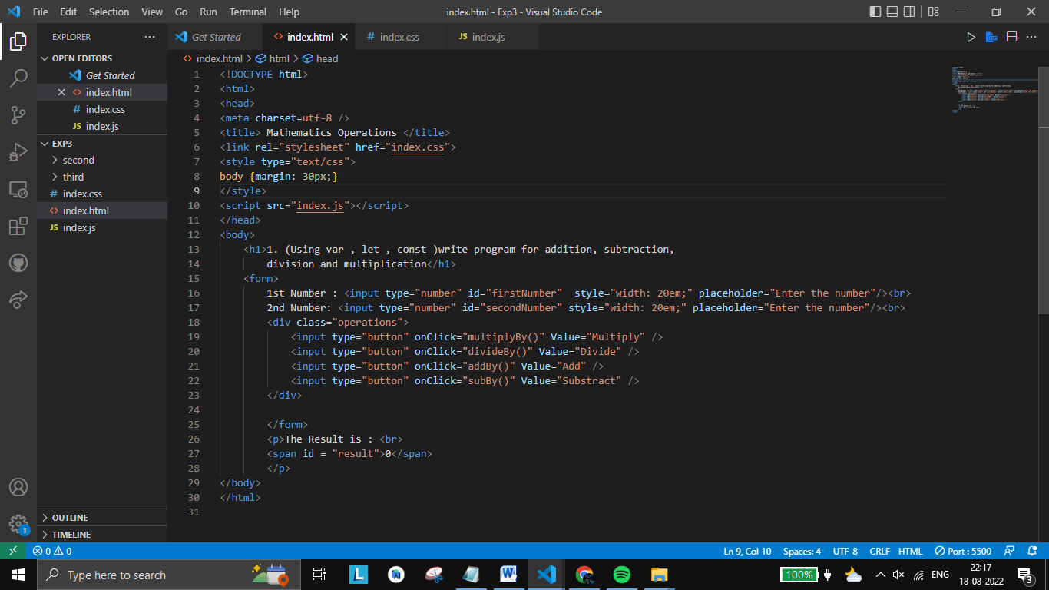

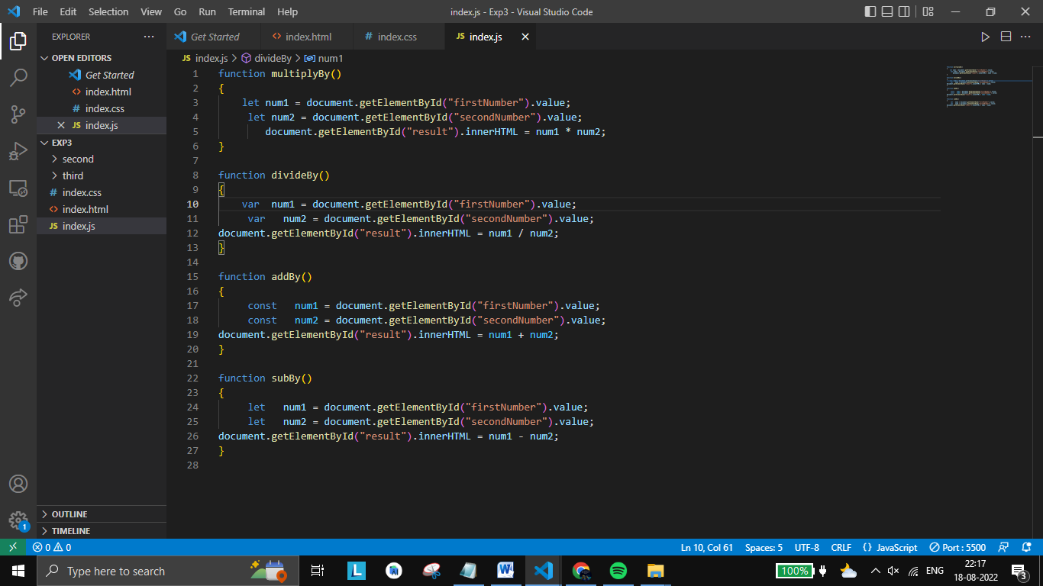

**Output :**

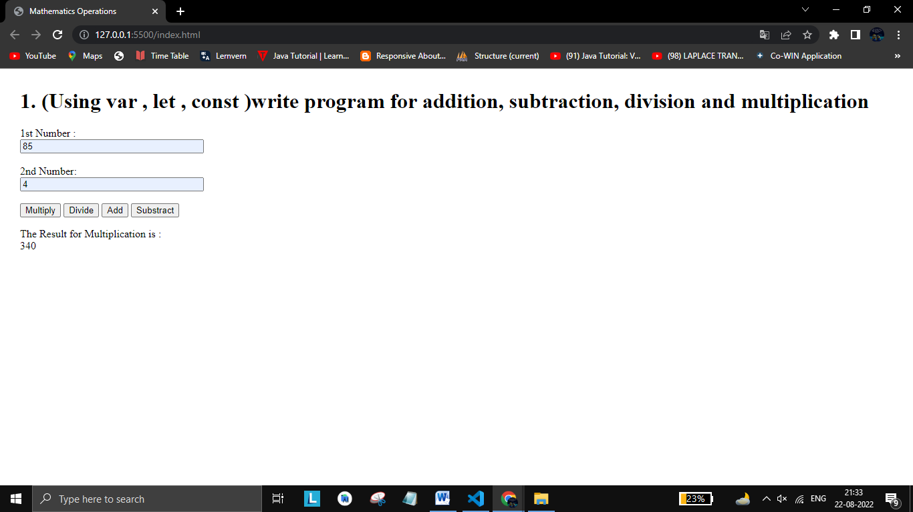

1. **(using conditions FOR, IF ELSE, Break, Continue) write a code for Persons age is eligible for Voting or not.**

**Theory :**

In JavaScript we have the following conditional statements:

Use if to specify a block of code to be executed, if a specified condition is true

Use else to specify a block of code to be executed, if the same condition is false

Use else if to specify a new condition to test, if the first condition is false

Use switch to specify many alternative blocks of code to be executed

**Example (1)**

if (hour < 18) {

greeting = "Good day";

} else {

greeting = "Good evening";

}

**Example (2)**

if (time < 10) {

greeting = "Good morning";

} else if (time < 20) {

greeting = "Good day";

} else {

greeting = "Good evening";

}

**Example (3)**

The for statement creates a loop with 3 optional expressions:

for (let i = 0; i < 5; i++) {

text += "The number is " + i + "<br>";

}

**Code :**

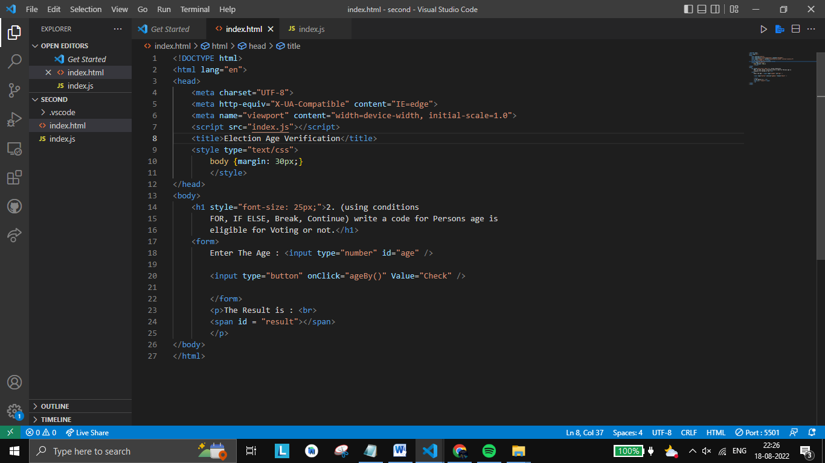

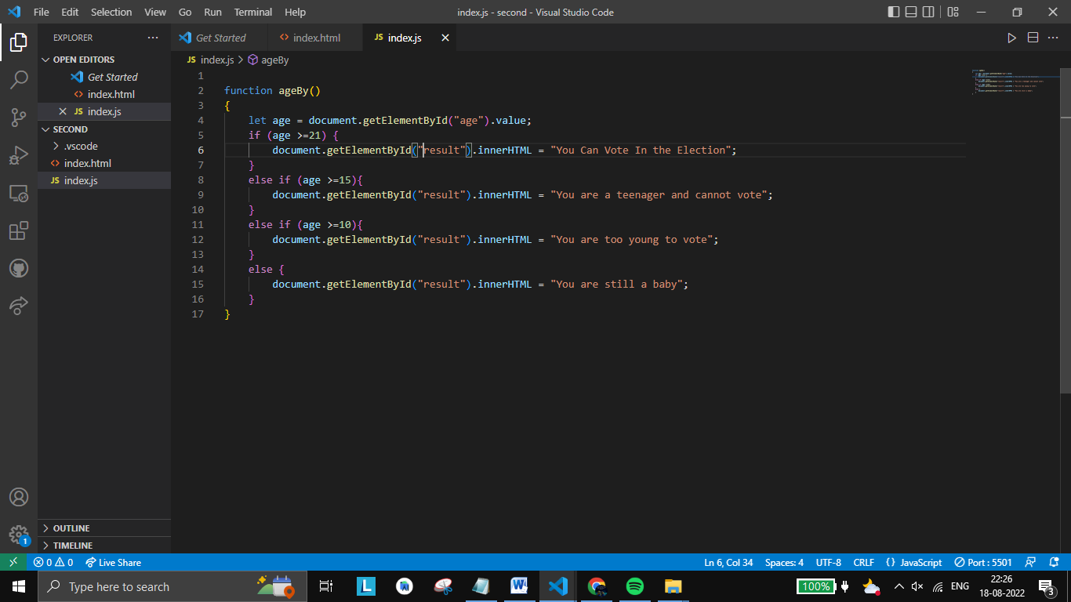

**Output :**

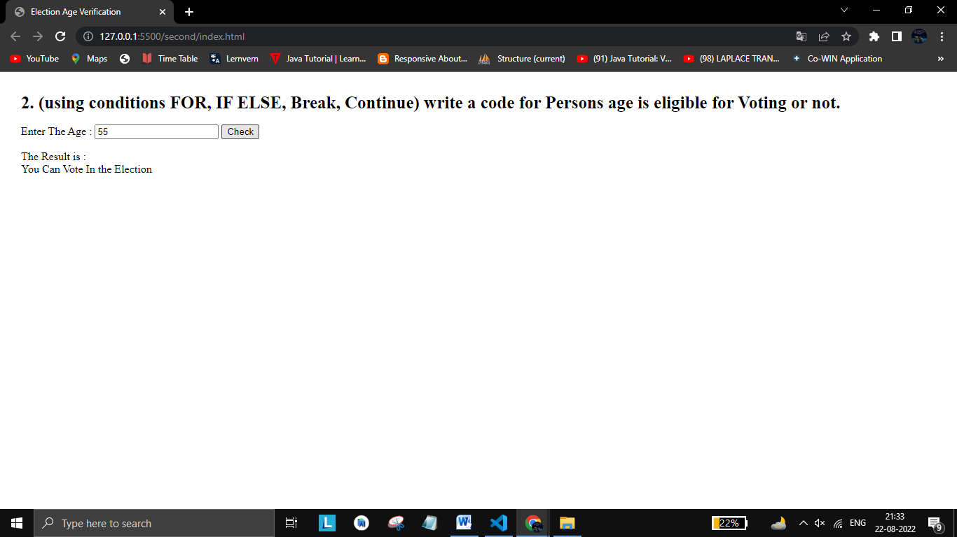

1. **LOOPING (While Loop , DO-while LOOP , Switch Case) Write a Program to find grade of student .**

**Theory :**

JavaScript supports different kinds of loops:

for - loops through a block of code a number of times

for/in - loops through the properties of an object

for/of - loops through the values of an iterable object

while - loops through a block of code while a specified condition is true

do/while - also loops through a block of code while a specified condition is true

**Example (1)**

The while loop loops through a block of code as long as a specified condition is true.

while (i < 10) {

text += "The number is " + i;

i++;

}

**Example (2)**

Use the switch statement to select one of many code blocks to be executed.

This is how it works:

The switch expression is evaluated once.

The value of the expression is compared with the values of each case.

If there is a match, the associated block of code is executed.

If there is no match, the default code block is executed.

switch(expression) {

case x:

// code block

break;

case y:

// code block

break;

default:

// code block}

**Code :**

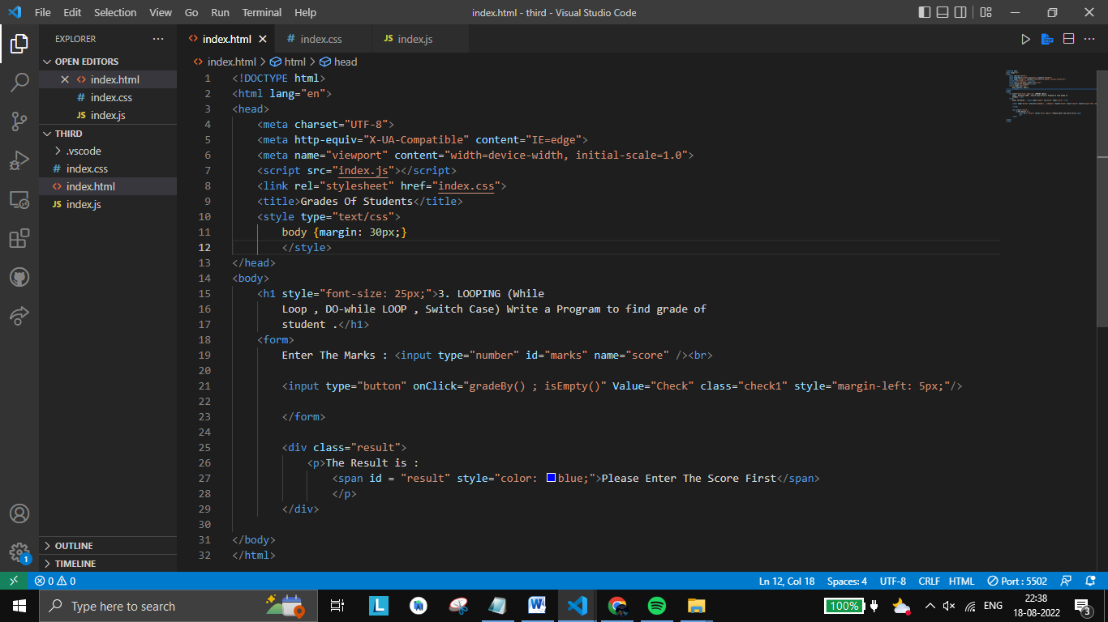

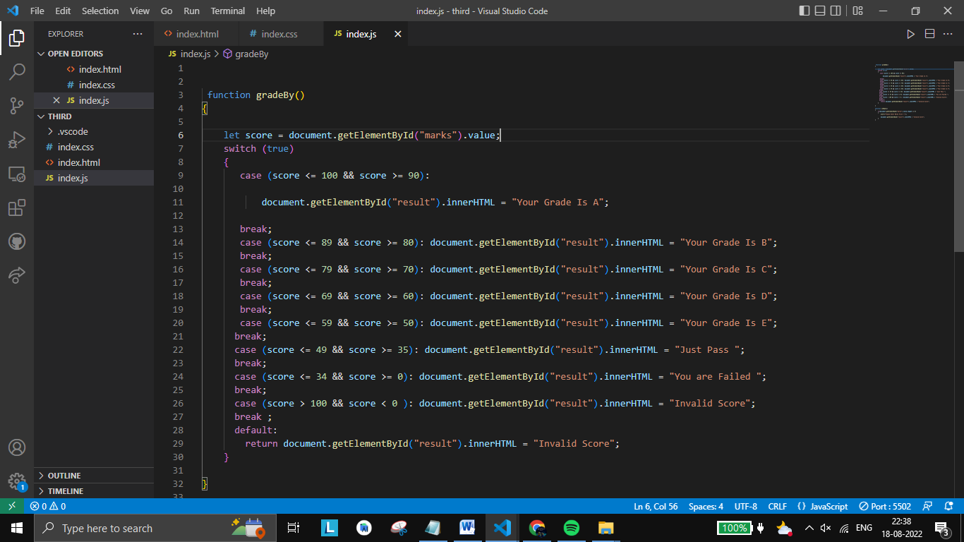

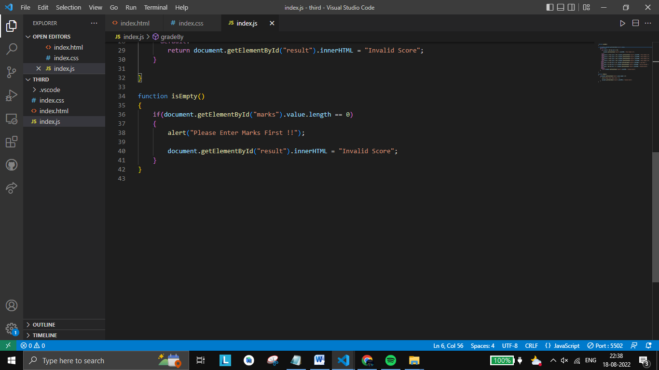

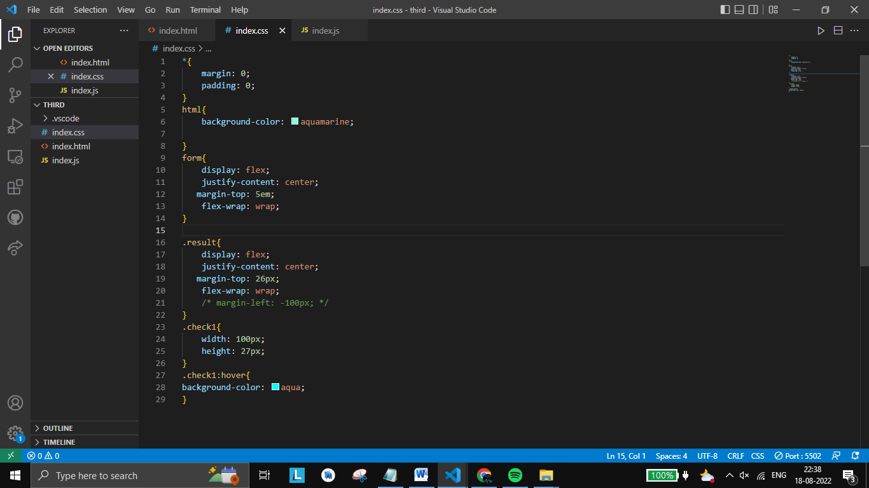

**Output :**

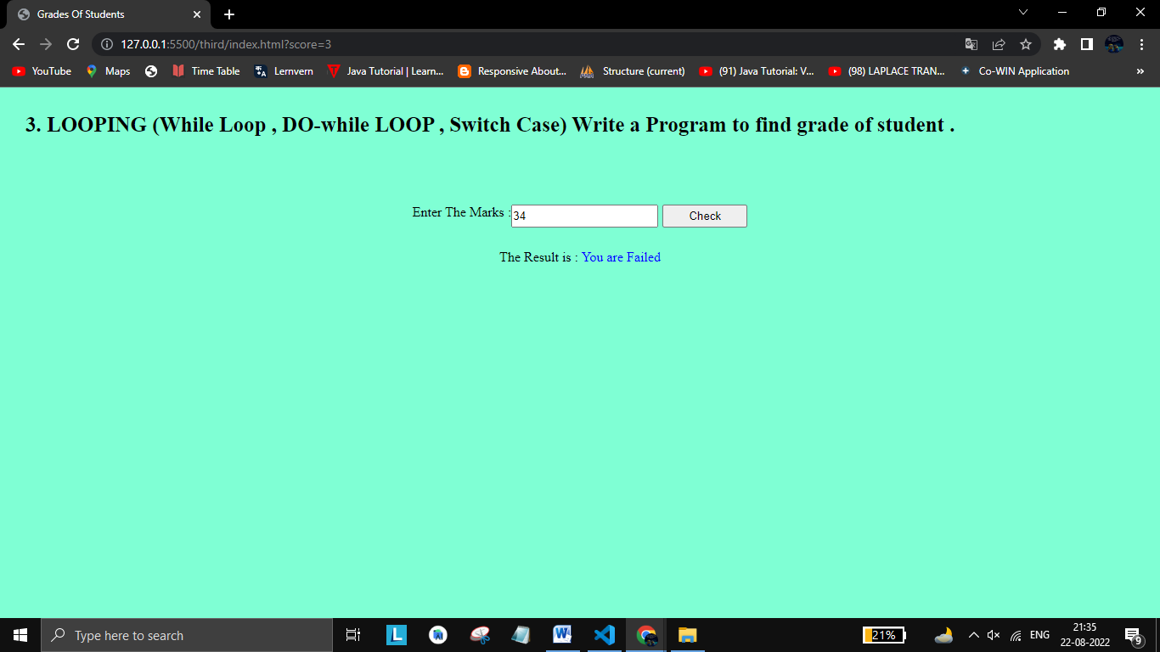

**Conclusion :** Therefore we have successfully implemented basics of javascript.